May 16, 2023
Todd Sherman
Design Build Homes
11400 SE 8th, Suite 415
Bellevue, WA 98004

Site: 4719 86th Ave SE
Mercer Island, WA 98040
TPN: 7598100421
Area: 11,500 sq ft. = .26 acres

Re: 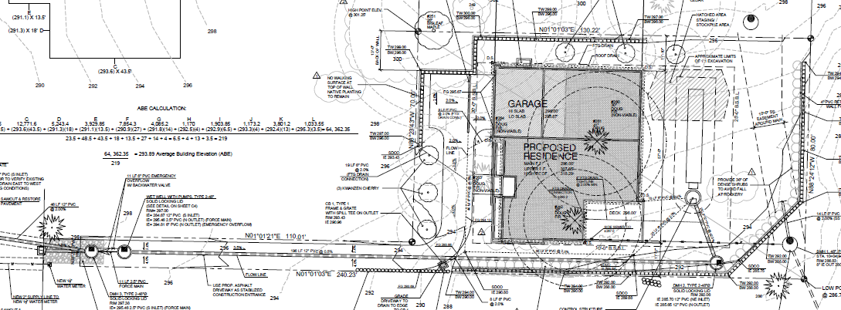RFI; Comments addressed below, as well as in the report, all changes are highlighted in yellow

3. (for civil provided during intake screening) Show arborist provided driplines for all trees on a tree protection plan. Include all tree and civil information on one plan. Show tree protection for evergreens at the entrance of the properties on adjacent properties. This tree protection must be entirely on site and not on adjacent property. See checklist for the tree protection plan requirements. https://www.mercerisland.gov/sites/default/files/fileattachments/community_planning_amp_development/page/21988/treessubmittalchecklist.pdf (completed D.R. Strong)
Building review:
4. (for architect) Provide the surveyed location of all large trees and exceptional trees on the property.
(Completed McCullough)
Information provided by survey and shown on civil sheets – must need to be on architectural plans
1. (provided during pre-application meeting for the adjacent parcel and intake screening) The project must meet the requirements in 19.10.060. This includes the requirements of saving at least 30% of regulated trees. And all exceptional trees. See the attached emailed code matrix that you must complete to show you have met the code. You must complete all code tabs at the bottom of excel sheet. 19.10.060 is highlighted because of its importance on this project. You may only remove exceptional trees after this exercise takes place and you find, retaining the tree would limit the constructible gross floor area to less than 85 percent of the maximum gross floor area per MICC 19.10.060.
Trees must be protected at Arborist given limits of allowable disturbance. Building pads must have a minimum 5-foot buffer to access and construct the building. As an example, placing a building pad 2-feet away from a tree will result in the tree being damaged and removed. (Completed)
Show the different options for building pad/utility placement/retaining walls that retain the largest number or best suitable for retention exceptional trees. (Is an east/west or north/south configuration best for tree retainage?)
Determine the allowed setbacks and maximum gross floor area and configure the building pad to best avoid any exceptional trees and retain 30 percent of large trees (what building can fit without encroaching into exceptional trees dripline). You may need to modify the traditional rectangle building pad to accommodate for exceptional trees dripline.
You must make the case in a narrative and plan showing you have followed these steps.
You may only remove the exceptional tree after this exercise takes place and you find, retaining the tree would limit the constructible gross floor area to less than 85% of the maximum gross floor area.
There are two (2) exceptional trees (#262 and #262) located in the proposed building site. Their dripline + 5’ buffer are shown on the Tree Retention Sheet. Permission to remove the two (2) trees is requested because the driveway is the maximum distance the fire Department will allow from the street. To more the house to a different location requires and increase in the driveway access which in turn makes the structure a fire hazard.
2. (for architect provided at intake screening) Provide a replanting plan according to the following At least half of the trees need to be Pacific Northwest native, see the following link. You are showing all non native species. https://your.kingcounty.gov/dnrp/library/water-and-land/yard-and-garden/native-plant-guide-western-washington.pdf. The trees need to be at least 10' apart from each other, structures, fences and utilities. If requested and you can show no room exists on site for all the trees, the remainder can be a fee in lieu if requested. A tree watering plan must also be provided to show the trees would survive long term. (see Architectural plans)
I coordinated my replanting efforts with the help of DR Strong (civil engineers) to meet code replanting requirements that each supplemental tree be 10’ from an existing building, retaining wall, utility corridor etc., using that information I determined that the maximum number onsite mitigated trees could not exceed six (6) trees. I relied on my landscape design degree to chose species of trees that were suitable to the habitat. The requirement that 50% of the tree be selected from “native” plant species lists although is a MICC requirement, is often the worst choice of plant material, and is often not feasible to do in the field (for example native trees, include red alders, cottonwoods, paper birch, black locust and many other pioneer species that are short lived and have a high risk of failure). I selected species that remained small and could adapt to the changes to the site hydrology that development causes.
5. Provide the required form showing at least the minimum amount of required trees protected on site HYPERLINK "https://www.mercerisland.gov/sites/default/files/fileattachments/community_planning_amp_development/page/21988/mercerislandtreeinventory.pdf" mercerislandtreeinventory.pdf (See Architecture plans)
*6. I located a tree in the ROW that has previously not been discussed and I am adding that now. I am presuming its removal will require an additional 3 trees for mitigation. The tree has been tagged #625 and is located on the north side of the property adjacent to a 10’ wide roadway access. The tree is viable and needs to be removed. I have updated the spreadsheet to include it in the discussion and modified my summary to consider the removal and mitigation.
The subject tree is a white pine, with a lean (self-corrected) to the east. The root ball is shallow (typical of the species) and soil is slightly elevated likely the consequence of a previous wind throw event. The roots that are preventing the tree from falling are located primarily on the east and south of the tree. Those roots need to be cut in order for the driveway to meet the grade of the street. There are no alternate pathways around this narrow driveway nor are their any construction BMP to span the roots and keep the tree, due to the elevation change to meet grade.
Applicant proposes to mitigate for the loss of the tree by replanting the same species 10’ further to the east in the easement.

Proposed Site Plan:

Summary:
Tree Density Calculations
Total number of onsite trees | 29
Total number of non-viable trees | 7
Total number of viable trees | 22
Number of onsite trees removed for site improvements | 12
Number of offsite trees removed for site improvements | 1
Total number of required tree credits (30% X 22) | 7
Total number of retained tree credits | 1
Mitigation:
Exceptional trees (6: 1) 2 | 12
Large trees 24"-36" (3:1) - 1 | 3
10"-24" (2:1) - 0 | 0
Offsite Large tree 24"-36" (3:1) - 1 | 3
Required Onsite Mitigation Total | 18
Actual Mitigation Total | 6
Total number of trees to pay fee -in-lieu-of | 12
Required Offsite Mitigation Total | 1

